Cables

🔌 What Are Cables in Networking?
# Source: AI Source: Provided by: [Data Path: Persons Table -> ID Column: 1, Name_En Column: Motasem Essam] -> From: [ChatGPT] on [12/18/2025]
Cables in networking are physical transmission media used to connect devices (like computers, routers, switches, and servers) and allow data, power, or signals to travel between them.

🧠 Key Purpose:
# Source: AI Source: Provided by: [Data Path: Persons Table -> ID Column: 1, Name_En Column: Motasem Essam] -> From: [ChatGPT] on [12/18/2025]
Cables form the wired backbone of a network, enabling data communication through electrical or optical signals.

🧾 Common Types of Network Cables:
# Source: AI Source: Provided by: [Data Path: Persons Table -> ID Column: 1, Name_En Column: Motasem Essam] -> From: [ChatGPT] on [12/18/2025]
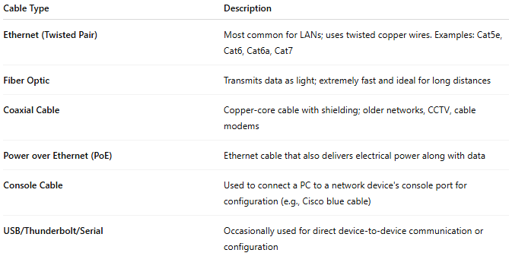

Cable Type | Description
Ethernet (Twisted Pair) | Most common for LANs; uses twisted copper wires. Examples: Cat5e, Cat6, Cat6a, Cat7
Fiber Optic | Transmits data as light; extremely fast and ideal for long distances
Coaxial Cable | Copper-core cable with shielding; older networks, CCTV, cable modems
Power over Ethernet (PoE) | Ethernet cable that also delivers electrical power along with data
Console Cable | Used to connect a PC to a network device's console port for configuration (e.g., Cisco blue cable)
USB/Thunderbolt/Serial | Occasionally used for direct device-to-device communication or configuration

📡 Cable Function Examples
# Source: AI Source: Provided by: [Data Path: Persons Table -> ID Column: 1, Name_En Column: Motasem Essam] -> From: [ChatGPT] on [12/18/2025]
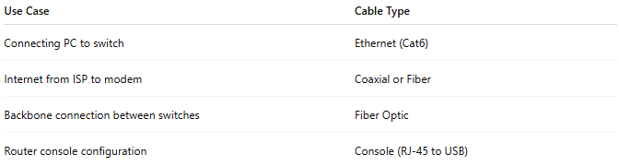

Use Case | Cable Type
Connecting PC to switch | Ethernet (Cat6)
Internet from ISP to modem | Coaxial or Fiber
Backbone connection between switches | Fiber Optic
Router console configuration | Console (RJ-45 to USB)

✅ Advantages of Cabled Networks
# Source: AI Source: Provided by: [Data Path: Persons Table -> ID Column: 1, Name_En Column: Motasem Essam] -> From: [ChatGPT] on [12/18/2025]
- 🔒 More secure than wireless
- ⚡ Faster and more reliable
- 📶 Not affected by wireless interference

❌ Disadvantages
# Source: AI Source: Provided by: [Data Path: Persons Table -> ID Column: 1, Name_En Column: Motasem Essam] -> From: [ChatGPT] on [12/18/2025]
- 🧱 Less mobile and harder to install or rearrange
- 🎯 Requires proper cable management
- 📏 Limited by maximum cable lengths

🎯 Summary
# Source: AI Source: Provided by: [Data Path: Persons Table -> ID Column: 1, Name_En Column: Motasem Essam] -> From: [ChatGPT] on [12/18/2025]
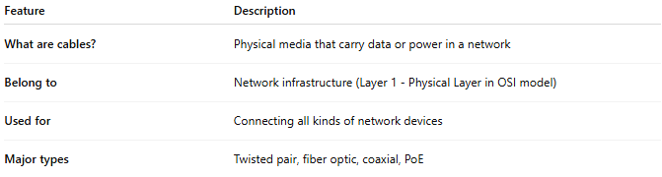

Feature | Description
What are cables? | Physical media that carry data or power in a network
Belong to | Network infrastructure (Layer 1 - Physical Layer in OSI model)
Used for | Connecting all kinds of network devices
Major types | Twisted pair, fiber optic, coaxial, PoE

